|  |  |
| --- | --- |
| Course Name | ITD 2313 – Script Programming |
| Instructor | Mark Pranger |
| Student Name | Josh Jones |
| Due date | May 19 |
| Grade | <grade earned here> |
| Grading Comments | <instructor comments here> |

Project #1:

I am unable to do this Project because the taxform file does not seem to be coming up on my IDLE

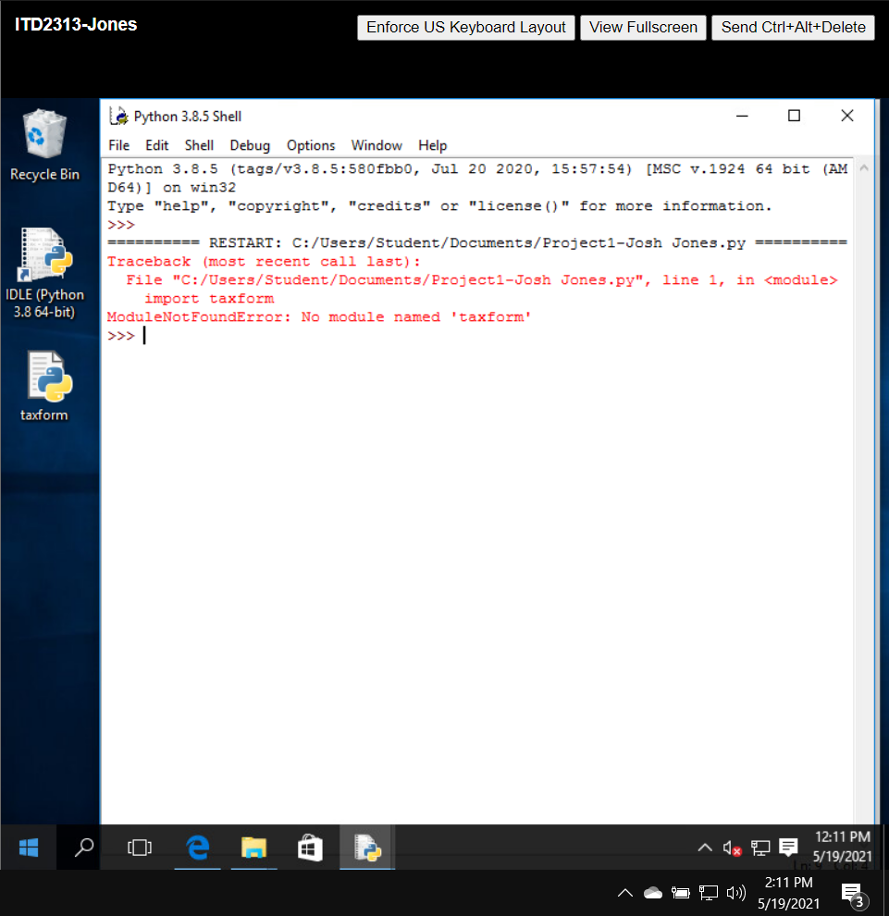

Project #9:

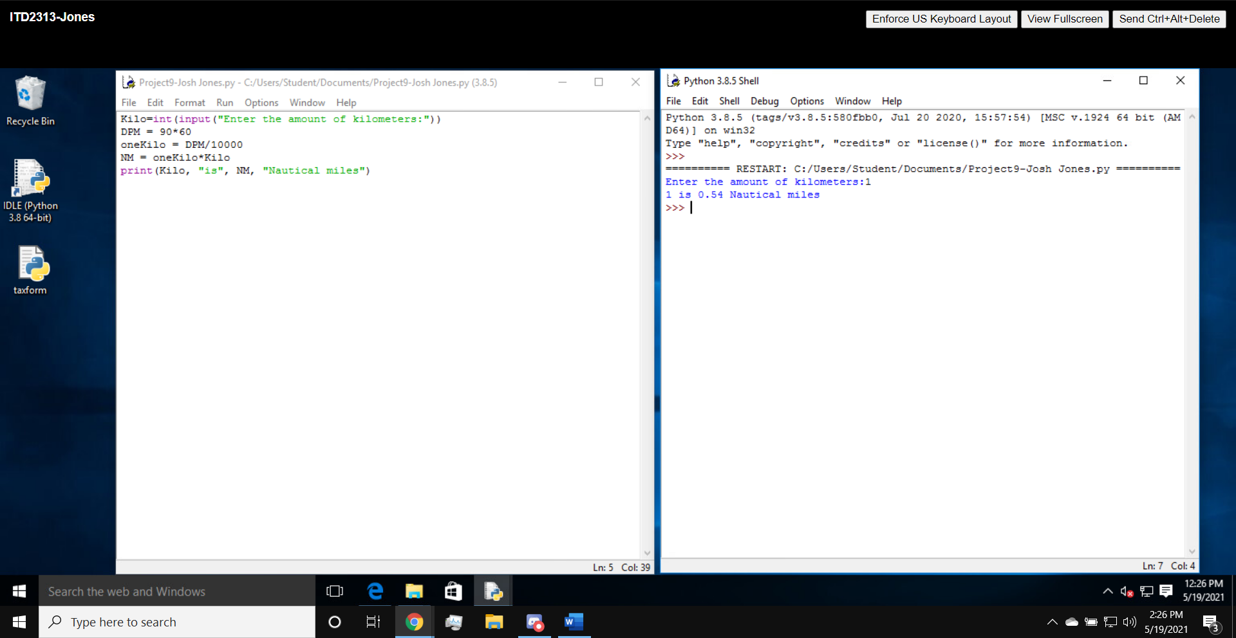

Project #10:

